# Assignment 2

**Name(s): Vaibhav Raheja**

**NetID(s): vraheja3**

In each the following parts, you should insert the following:

* Train/test loss plots
* Qualitative outputs for GT, No encoding, Basic Positional Encoding, and Fourier Feature Encoding

# Part 1: Low resolution example – SGD

## None Mapping:

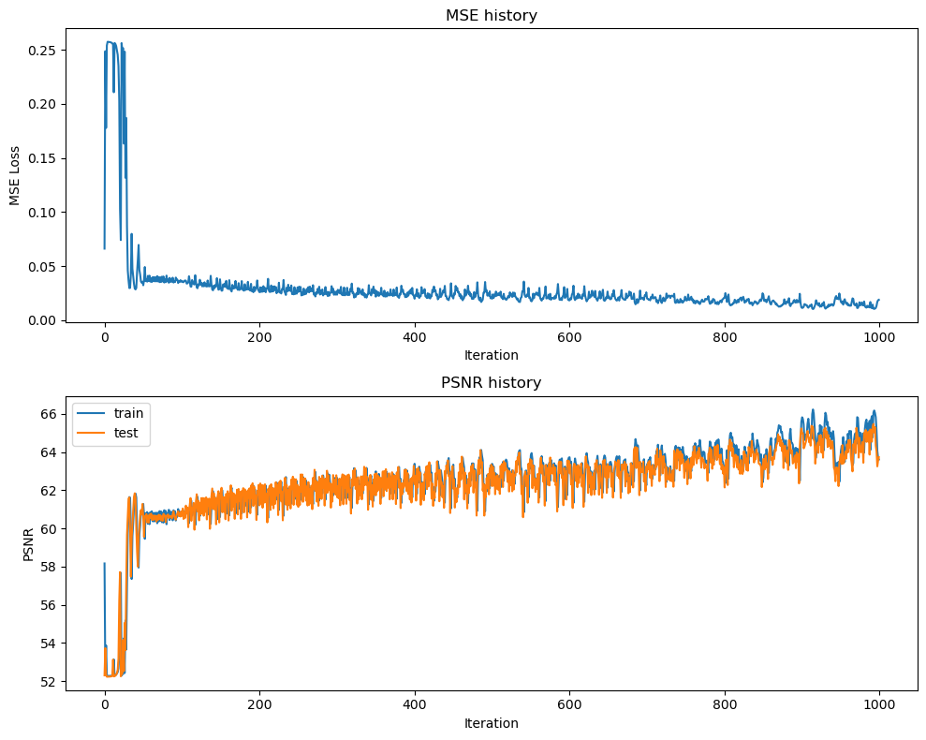

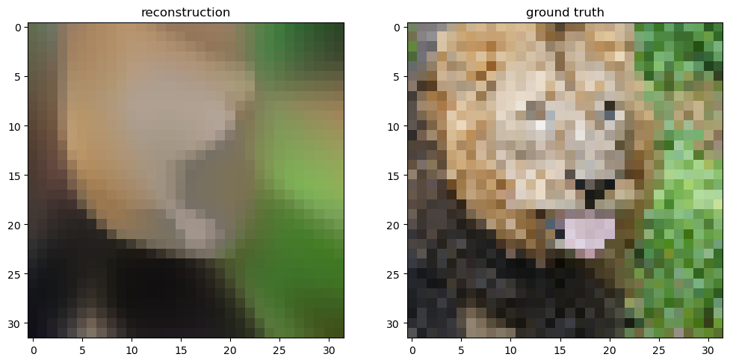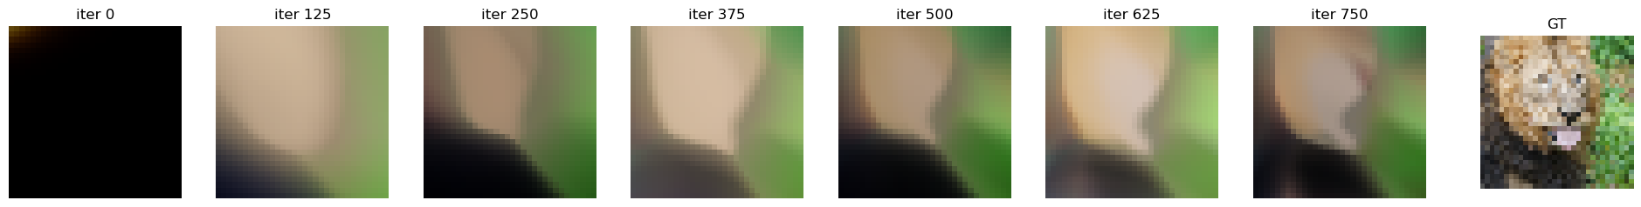

## Basic Mapping:

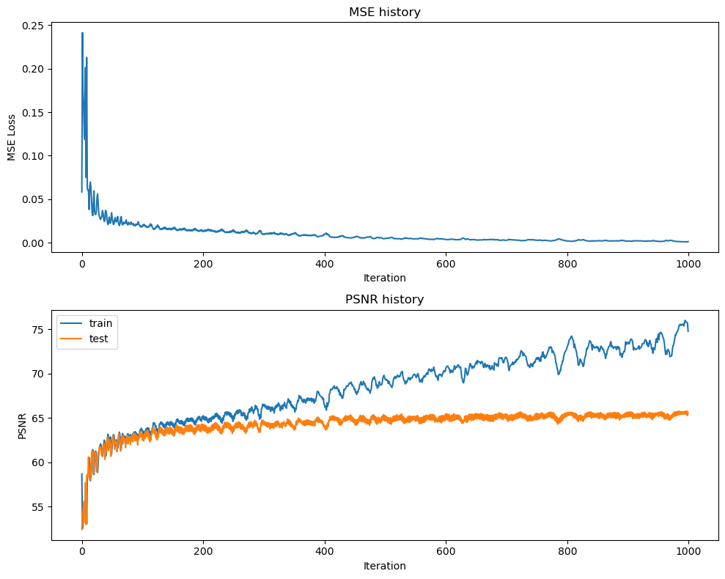

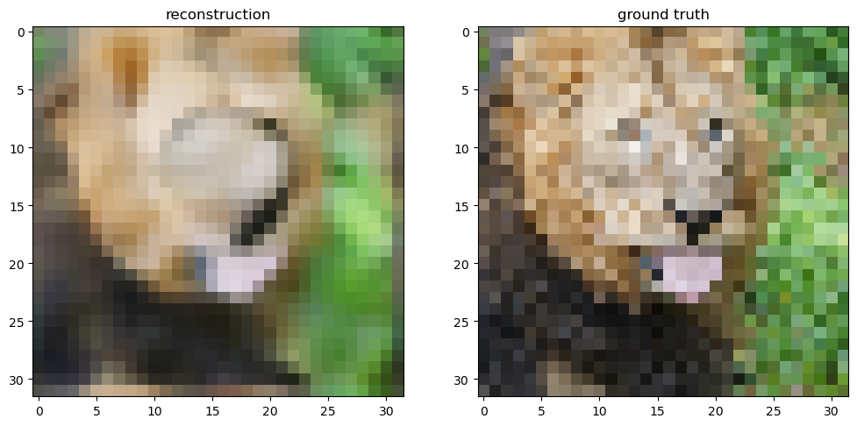

## Gaussian Mapping:

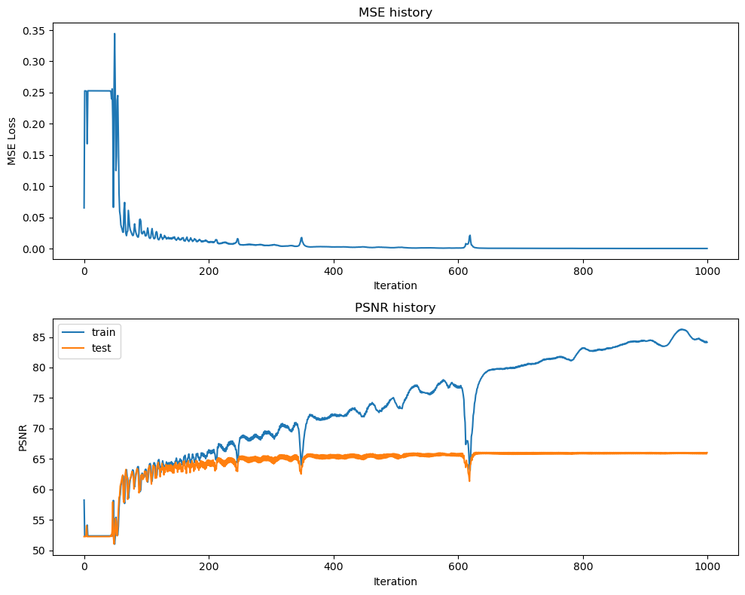 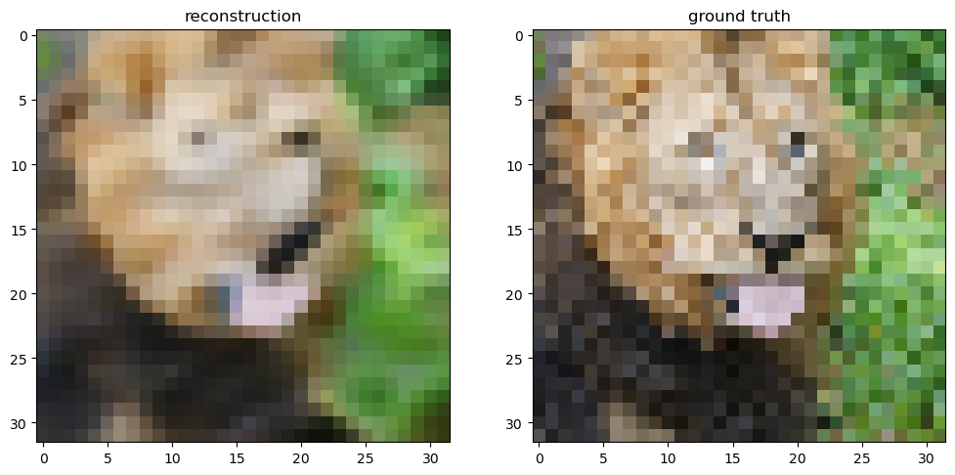

# Part 2: Low resolution example – Adam

## None Mapping:

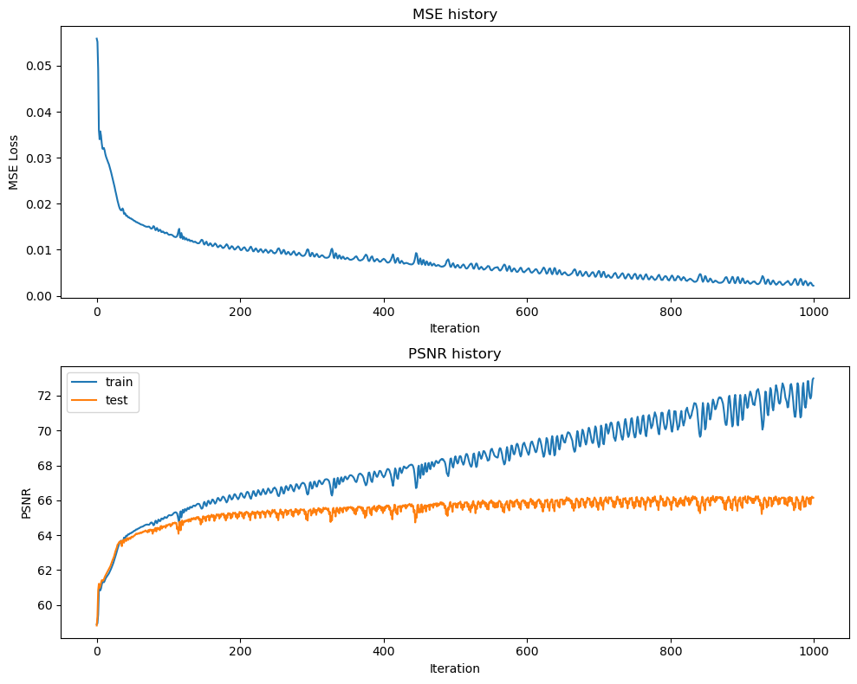

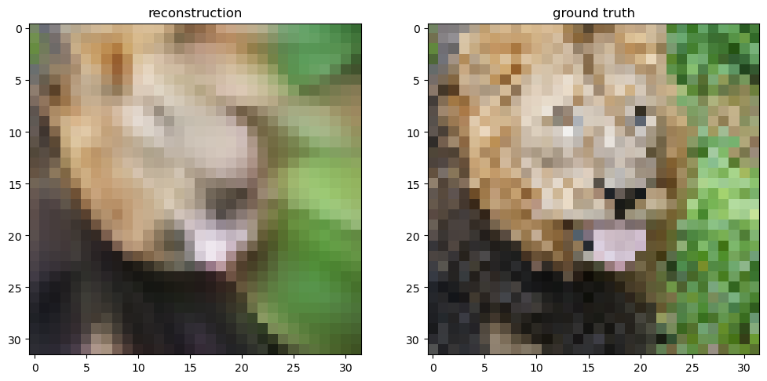

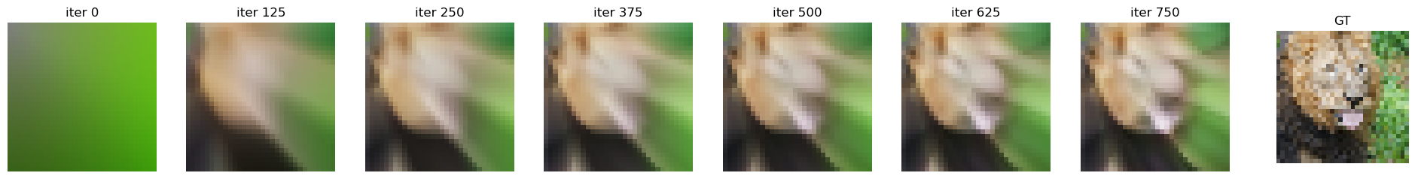

## Basic Mapping:

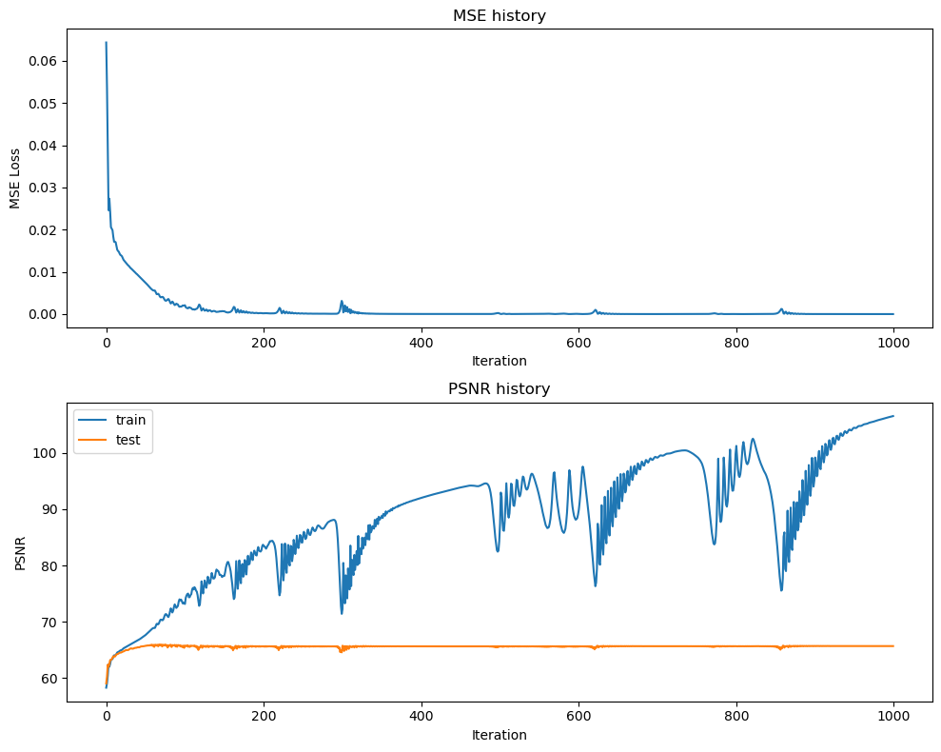 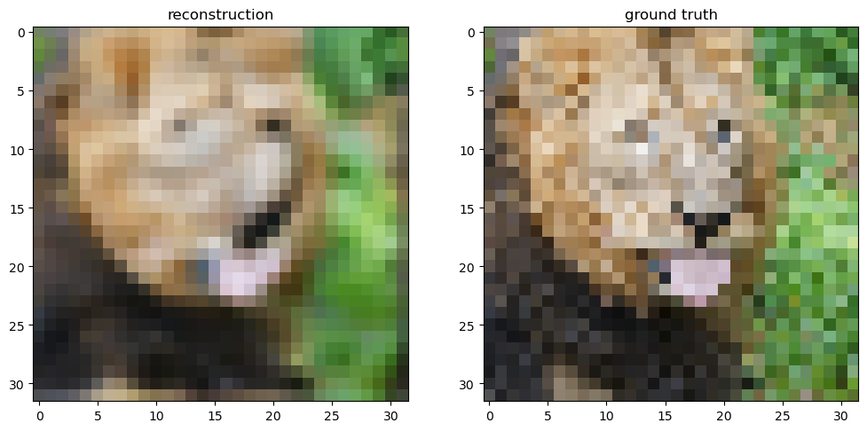

## Gaussian Mapping:

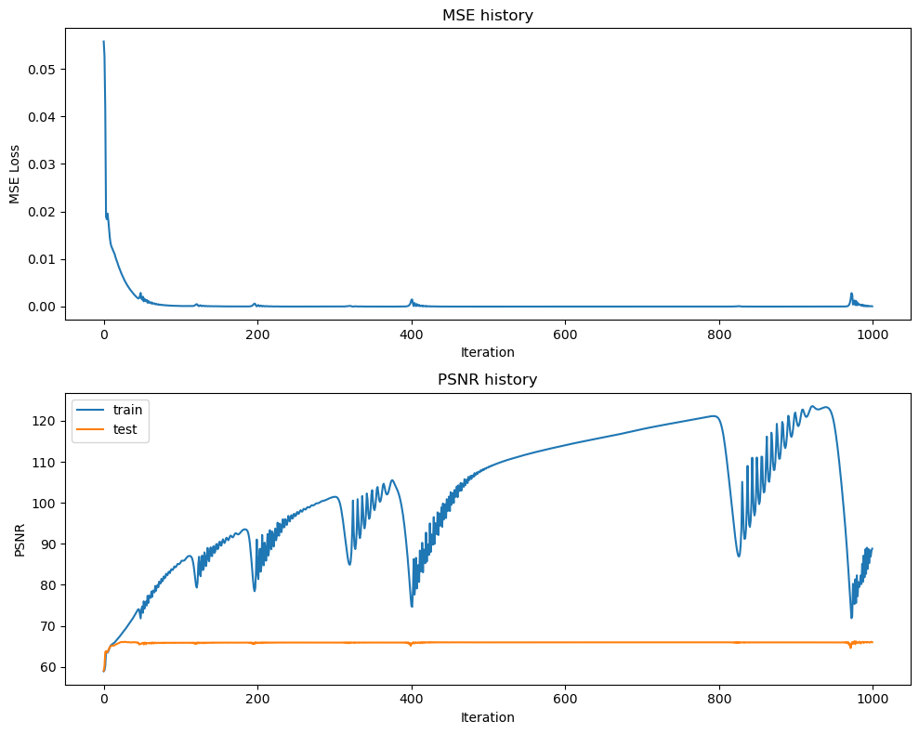

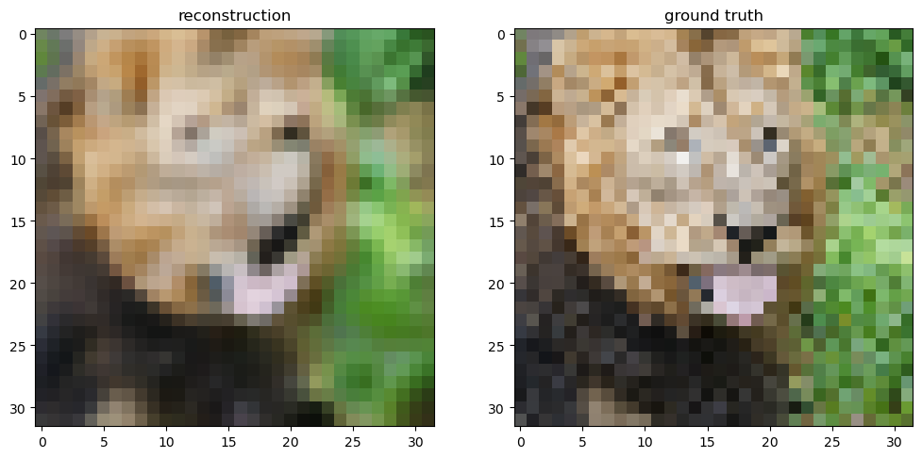

# Low resolution Compare:

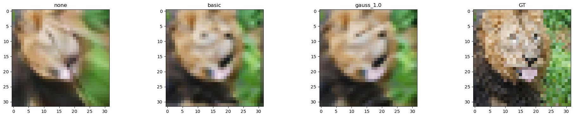

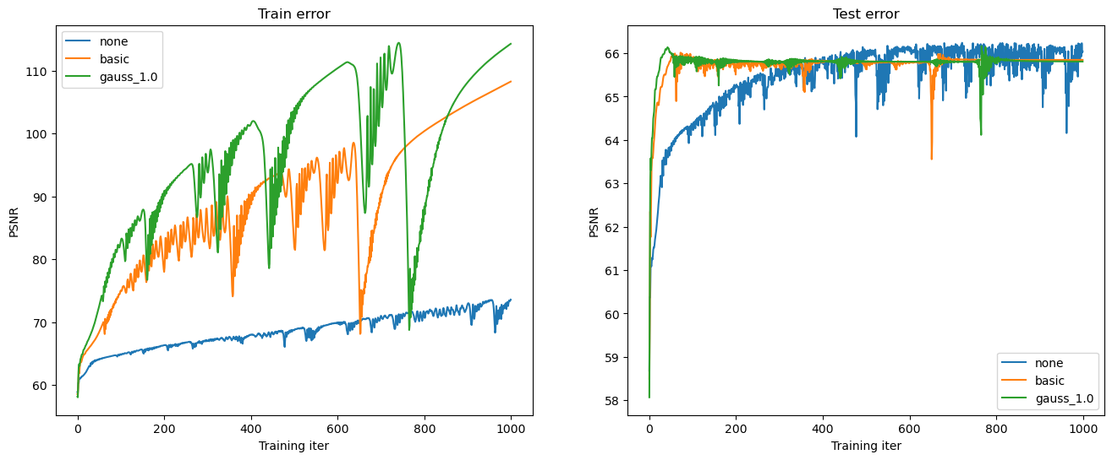

# Part 3: High resolution example

## Comparison:

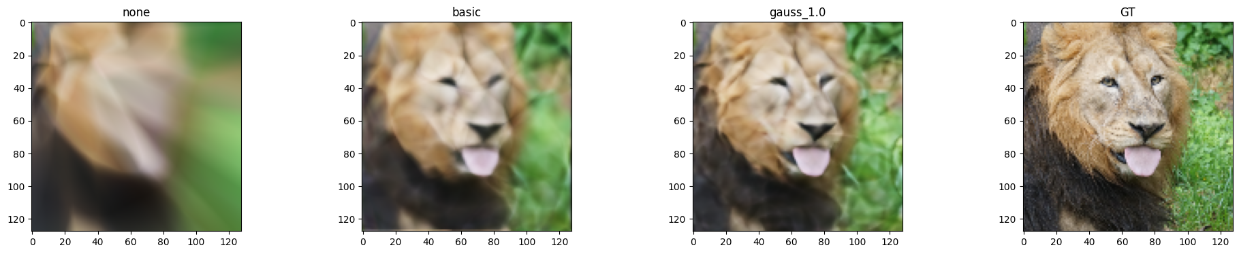

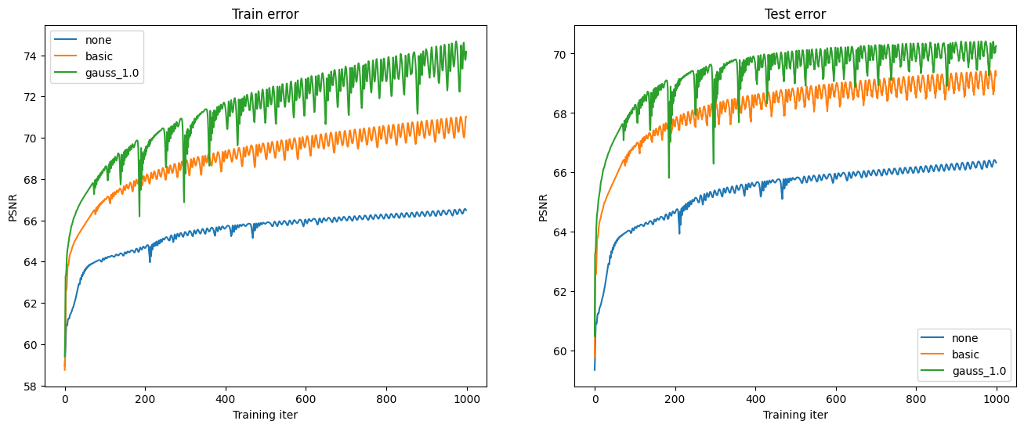

# Part 4: High resolution (image of your choice)

*(For this part, you can select an image of your choosing and show the performance of your model with the best hyperparameter settings and mapping functions from Part 3. You do not need to show results for all of the mapping functions.)*

## None Mapping:

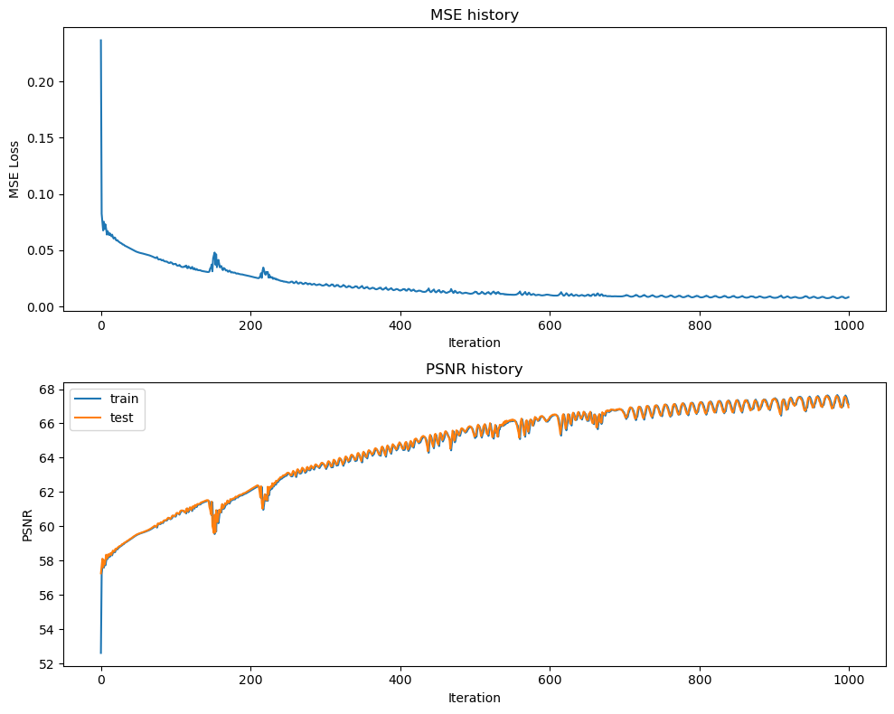 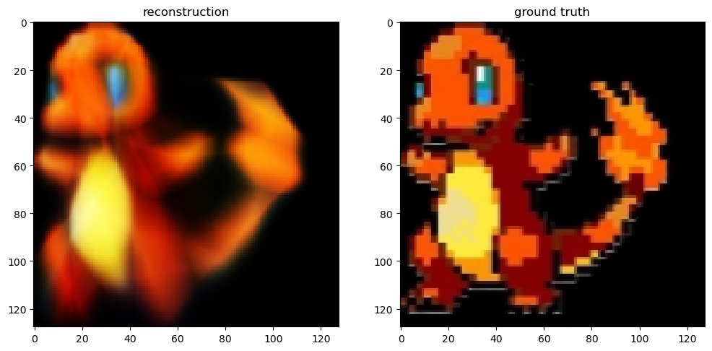

## Basic Mapping:

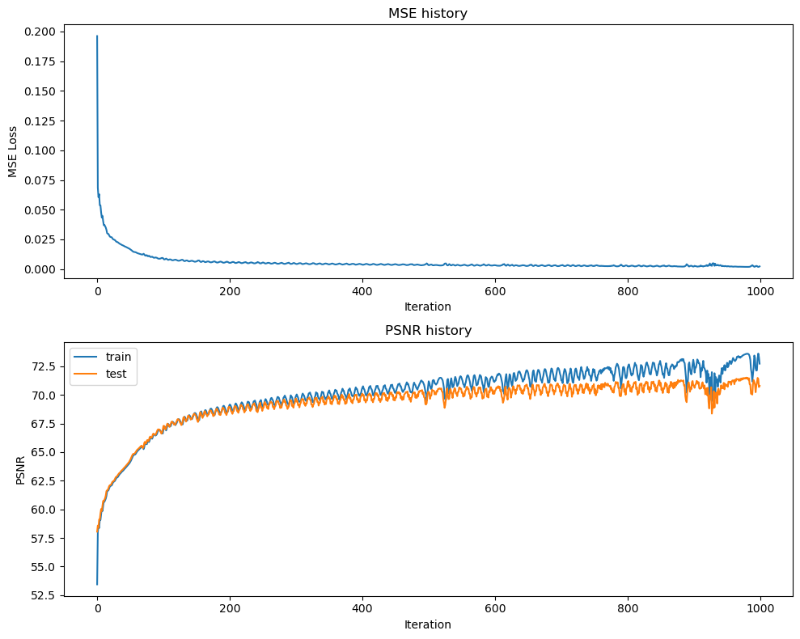 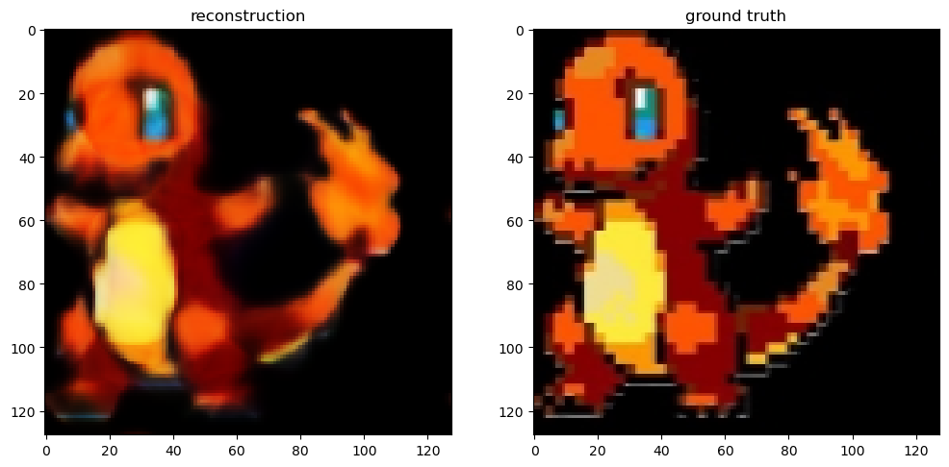

## Gaussian Mapping:

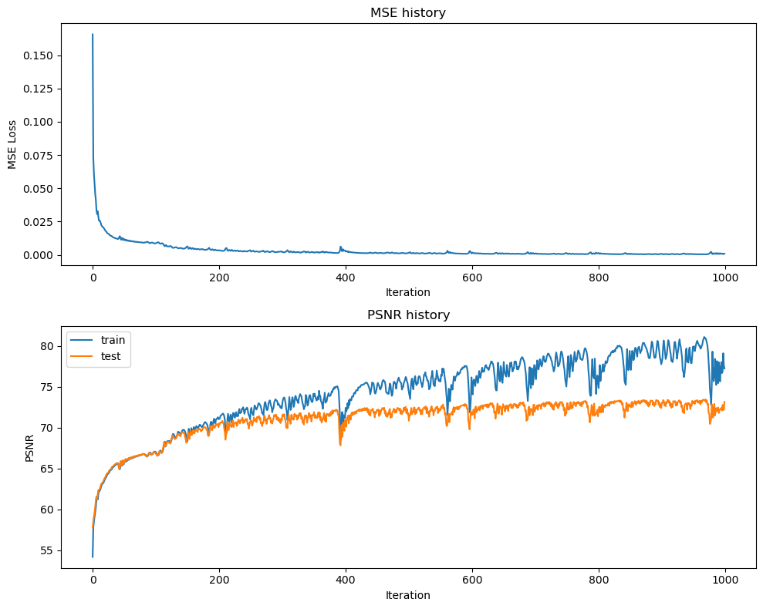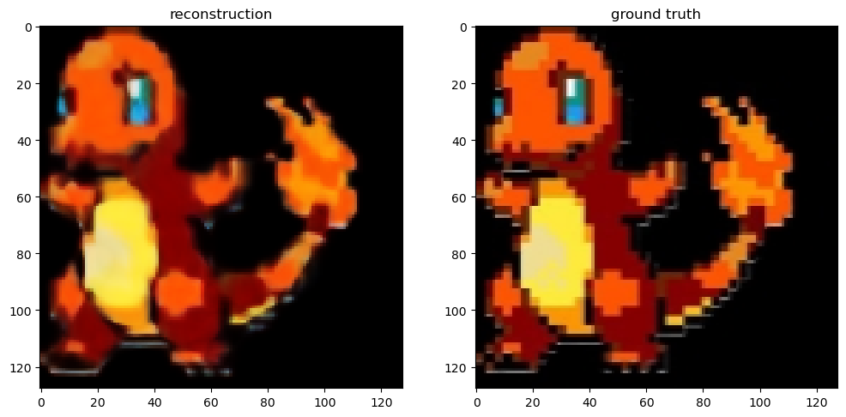

# Part 5: Discussion

*Briefly describe the hyperparameter settings you tried and any interesting implementation choices you made.*

I experimented with adjusting the learning rate to enhance the PSNR values using SGD and Adam optimizers. Initially, with default values, I achieved an average PSNR of 65. Through trial and error, I modified the learning rate, finding that increasing it to between 0.25 and 0.0075 boosted the PSNR to 66.07, improving image reconstruction. I also determined that 1000 epochs was the optimal setting for observing PSNR and MSE trends. For Adam I used a LR of 0.005 but giving me a PSNR of 65.7, but the reconstructed image was much closer to GT.

*How did the performance of SGD and Adam compare?*

Adam optimizer demonstrated faster convergence than SGD over 1000 epochs. Although, SGD was generally quicker for training due to less computational demand. Adam resulted in more structured image reconstruction across all coordinate mapping functions.

*How did the different choices for coordinate mappings functions compare?*

No Encoding produced blurry reconstructions with poor feature separation. For Basic Positional Encoding slightly improved image clarity and structure, and the Gaussian Feature Encoding yielded reconstructions closest to the ground truth, particularly excelling with the Adam optimizer and demonstrating the lowest test errors.

*Do you make any interesting observations from the train and test plots?*

PSNR values for the test set increased with oscillations, indicating fluctuating Neural Network performance improvement rates. All mapping functions showed a decrease in error rates over time, with Fourier Feature Encoding showing the lowest errors, proving its efficacy.

*What insights did you gain from your own image example (Part 4)?*

I chose a Charizard image to analyze foreground-background reconstruction. Mapping functions varied in effectiveness, with Gaussian mapping showing less bleeding and better feature separation.Minor details were more distinct with Gaussian mapping, demonstrating its superiority in preserving details. Adam optimizer consistently outperformed SGD, confirming its advantage across different images.